REVIEW AND PRACTICE PRACTICAL

TASK1: Open Cisco Packet Tracer and create a new project file named 'HomeWiFiNetwork.pkt' with three PCs and one wireless router connected appropriately.
- Opened Cisco Packet Tracer.
- Clicked File → New.
- Saved the project as HomeWiFiNetwork.pkt.
- Added 1 Wireless Router (Home Router) to the workspace.
- Added 3 PCs.
- Connected each PC to the router using Copper Straight-Through Cable from the PC's FastEthernet0 port to the router's LAN ports.
NETWORK TOPOLOGY
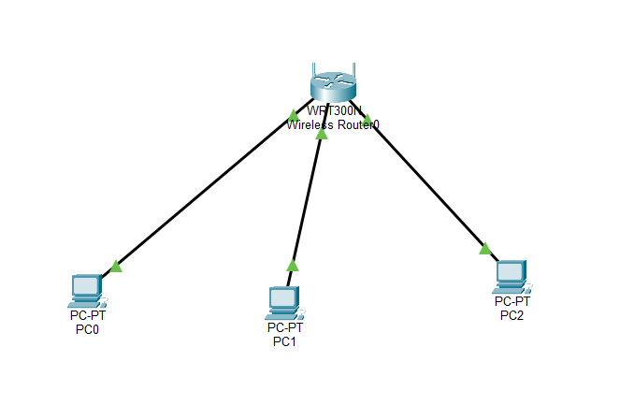

TASK2: Assign static IP addresses to each PC in your Packet Tracer network so they are on the same subnet (e.g., 192.168.10.x), and configure the default gateway to the router's IP.
Device | IP Address
Wireless Router | 192.168.10.1

PCI1
- IP Address: 192.168.10.2
- Subnet Mask: 255.255.255.0
- Default Gateway: 192.168.10.1
PC2
- IP Address: 192.168.10.3
- Subnet Mask: 255.255.255.0
- Default Gateway: 192.168.10.1
PC3
- IP Address: 192.168.10.4
- Subnet Mask: 255.255.255.0
- Default Gateway: 192.168.10.1

TASK3: Test connectivity by using the Packet Tracer 'ping' tool to verify that all PCs can communicate with each other and the router.<br><br><em><strong>Hint:</strong> Use the Command Prompt tool on each PC and type 'ping [other PC’s IP]'.</em>
- Opened PC1.
- Selected Desktop → Command Prompt.
- Typed: ping 192.168.10.3
- Pressed Enter.
- Repeated the test from each PC to the other PCs and to the router.
COMMAND USED:
ping 192.168.10.1
ping 192.168.10.2
ping 192.168.10.3
ping 192.168.10.4

TASK4: Document each step you took to build and configure your Packet Tracer network, including screenshots of your topology and the IP configuration windows for each PC, in a Word or PDF file.

Step 1
Opened Cisco Packet Tracer and created a new project named HomeWiFiNetwork.pkt.
Step 2
Added one wireless router and three PCs to the workspace.
Step 3
Connected each PC to the router using Copper Straight-Through cables.
Step 4
Configured static IP addresses for all three PCs:
- PC1 → 192.168.10.2
- PC2 → 192.168.10.3
- PC3 → 192.168.10.4
Configured the default gateway on each PC as 192.168.10.1.
Step 5
Opened the Command Prompt on each PC and used the ping command to test communication with the other PCs and the router.
Step 6
Verified that all ping requests were successful.

